Laptop Request Catalog Item

Team ID: NM2025TMID17590

Team Size: 5

Team Leader: ASWINI M

Team member: SHARMILA R

Team member: SUJITHRA J

Team member: SOWMIYA B

Team member: HAAFIYA A

**Problem Statement:**

Employees in the organization need a quick and efficient way to request laptops for work. The current process is manual and prone to delays, with no dynamic form behavior to guide users or ensure accurate data collection. To address this, a Service Catalog item needs to be created, allowing users to easily request a laptop, with dynamic fields, clear instructions, and additional functionality like resetting the form if needed. The solution should also ensure all changes are tracked for governance and deployment.

**Objective:**

1. **Define Requirements:** Identify the necessary fields and functionality for the laptop request form, such as:

* Employee details (name, email, department)
* Laptop specifications (type, model, operating system)
* Business justification for the request

Dynamic fields (e.g., dependent fields that change based on user input)

2. **Design the Form:** Create a user-friendly form with clear instructions and dynamic behavior, using a Service Catalog platform (e.g., ServiceNow).

3. **Configure Dynamic Fields:** Set up dynamic fields that change based on user input, such as:

* Dependent fields (e.g., laptop model options change based on selected type)
* Conditional logic (e.g., show/hide fields based on user input)

4. **Add Reset Functionality:** Include a reset button that clears the form and resets dynamic fields to their default state.

5. **Implement Governance and Tracking:** Configure the system to track all changes made to the form and requests, including:

* Audit logs
* Change history
* Request status updates

6. **Test and Refine:** Test the Service Catalog item and refine it based on user feedback and testing results.

7. **Deploy and Train:** Deploy the Service Catalog item and provide training to employees on how to use it.

**Skills:**

1. **ServiceNow Development:** Knowledge of ServiceNow platform, including creating Service Catalog items, forms, and workflows.

2. **Form Building:** Experience with designing and building forms with dynamic behavior, conditional logic, and dependent fields.

3. **Workflow Automation:** Understanding of workflow automation and how to create workflows that integrate with the Service Catalog item.

4. **Scripting:** Familiarity with scripting languages like JavaScript or Jelly scripting for advanced form behavior and automation.

**Update Set**

**Create Local Update Set**

1.Open service now.

2.Click on All >> search for update sets

3.Select local update sets under system update sets

4.Click on new

5.Fill the following details to create a update set as: “Laptop Request”

6.Click on submit and make current

7.By clicking on the button it activates the update set.

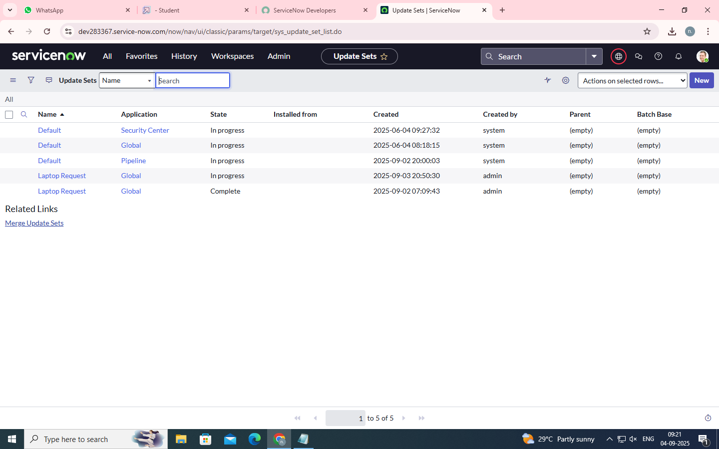

**Service Catalog Item**

**Create Service Catalog Item**

1.Open service now.

2.Click on All >> service catalog

3.Select maintain items under catalog definitions

4.Click on New.

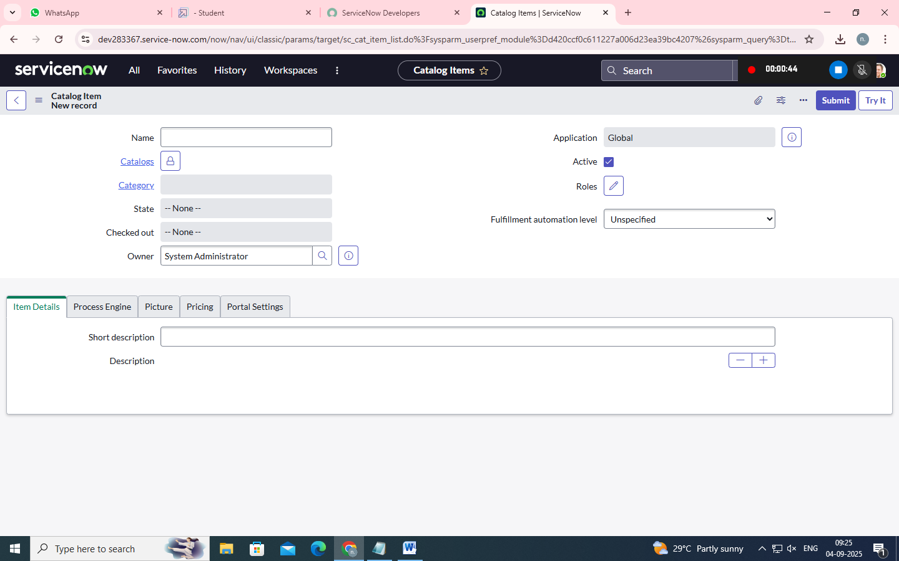

5.Fill the following details to create a new catalog item

Name: Laptop Request

Catalog: service Catalog

Category: Hardware

Short Description: Use this item to request a new laptop

6.Click on ‘SAVE’

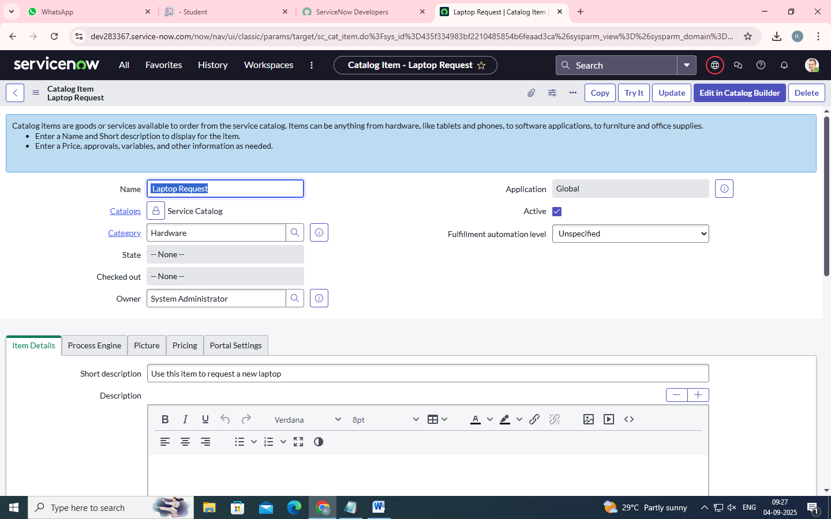

**Add variables**

Step1:

•After saving the catalog item form scroll down and click on variable(related list)

•Click on new and enter the details as below

1. Variable 1:Laptop Model

Type: Single line text

Name: laptop_model

Order:100

•Click on submit

•Again click on new and add Remaining variables in the above process

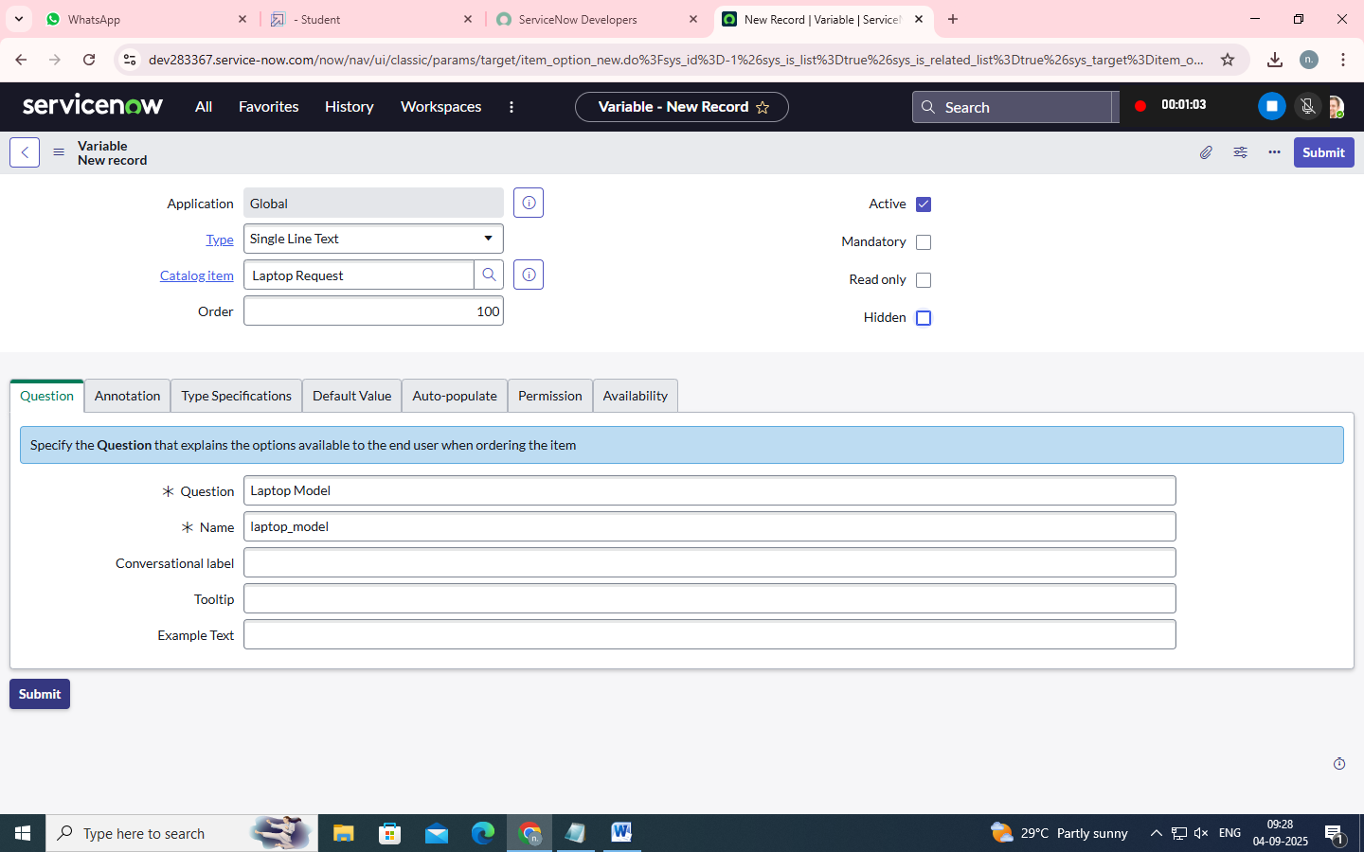

2. Variable 2:Justification

Type: Multi line text

Name: justification

Order:200

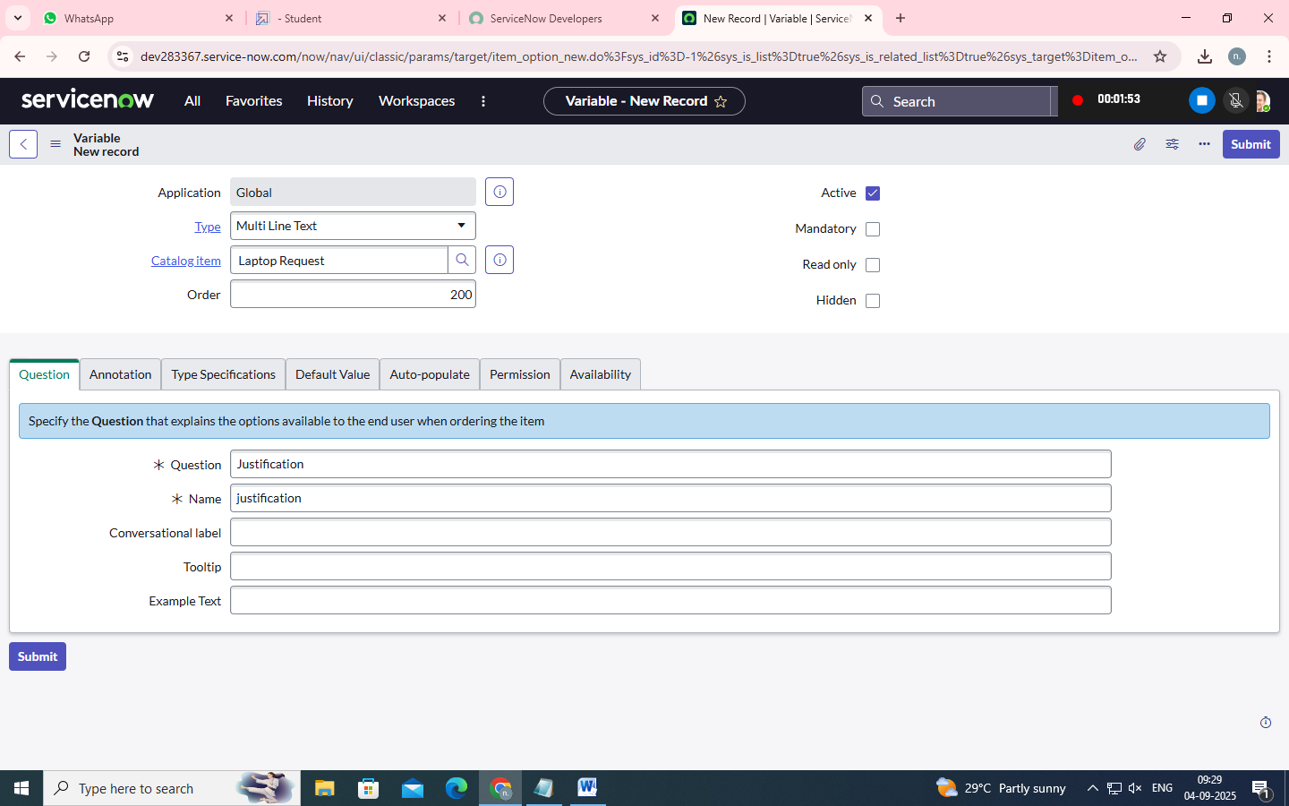

3. Variable 3:Additional Accessories

Type: Checkbox

Name: additional_accessories

Order:300

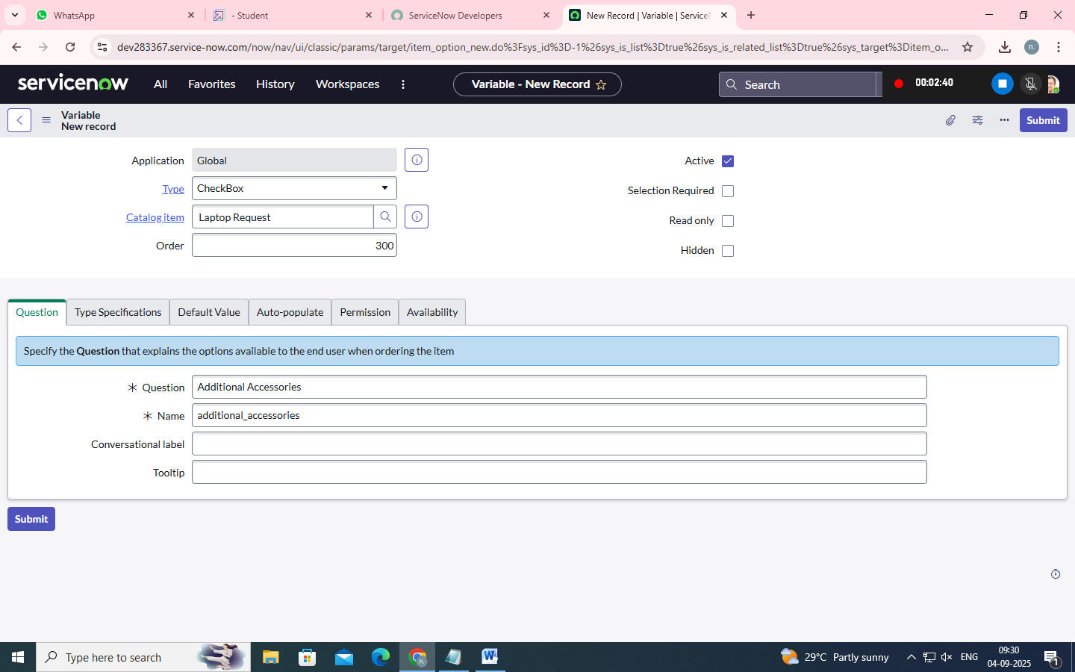

4. Variable 4: Accessories Details

Type: Multi line text

Name:accessories_details

Order:400

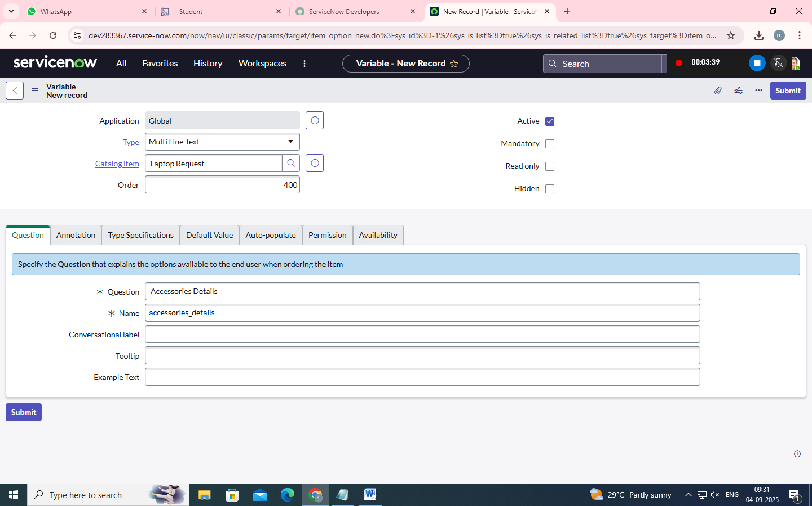

Step2:

•After adding above variable which are added to newly created catalog item

•Then save the catalog item form

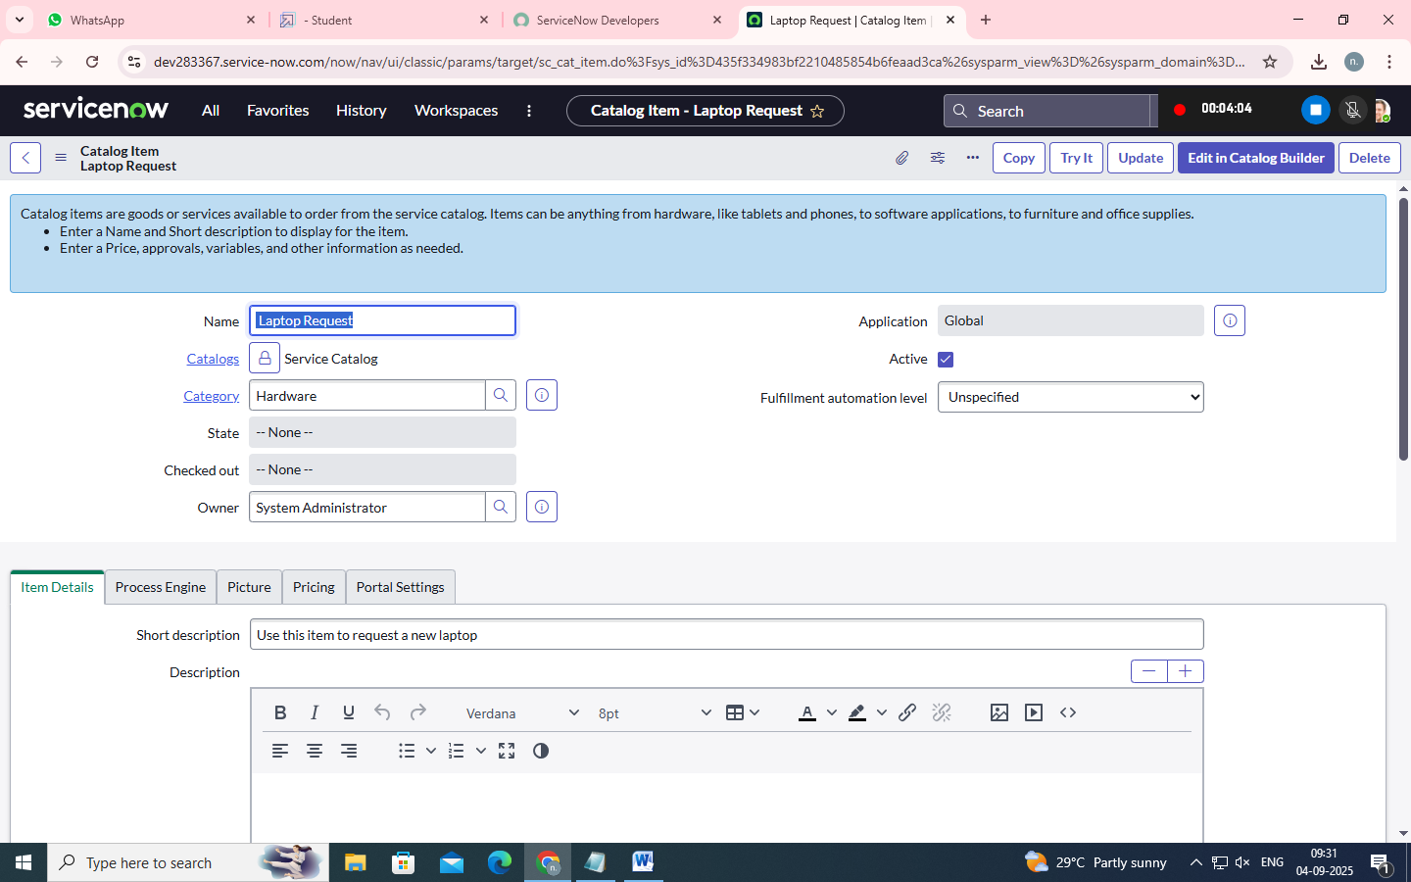

Ui Policy

**Create Catalog Ui Policies**

1.Click on all>> search for service catalog

2.Select maintain item under catalog definition

3.Search for ‘laptop request’ which is created before

4.Select ‘laptop request’ and scroll down click on “Catalog Ui policies”

5.In the catalog ui policies related list tab click on new

6.Give short description as: show accessories details

7.Set the Catalog Condition in the related list tab ‘when to apply’

[field: additional_ accessories, operator: is, value: true]

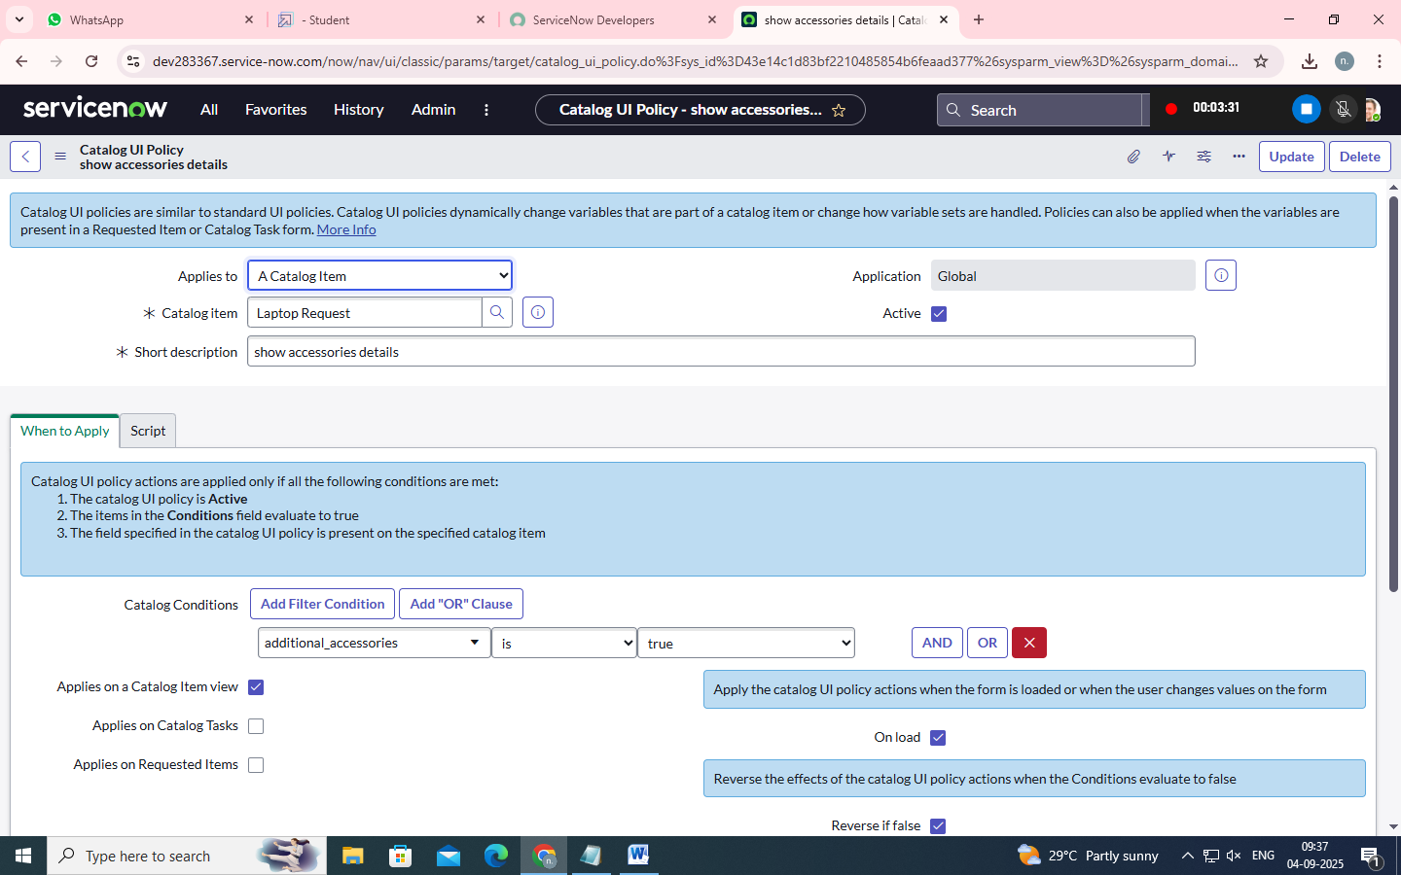

8.Click on save. (do not click on submit)

9.Scroll down and select ‘catalog ui action’

10.Then click on new button

11.Select variable name as: accessories_details

Order:100

Mandatory: True

Visible : True

12.Click on save and again click save button of the catalog ui policy form

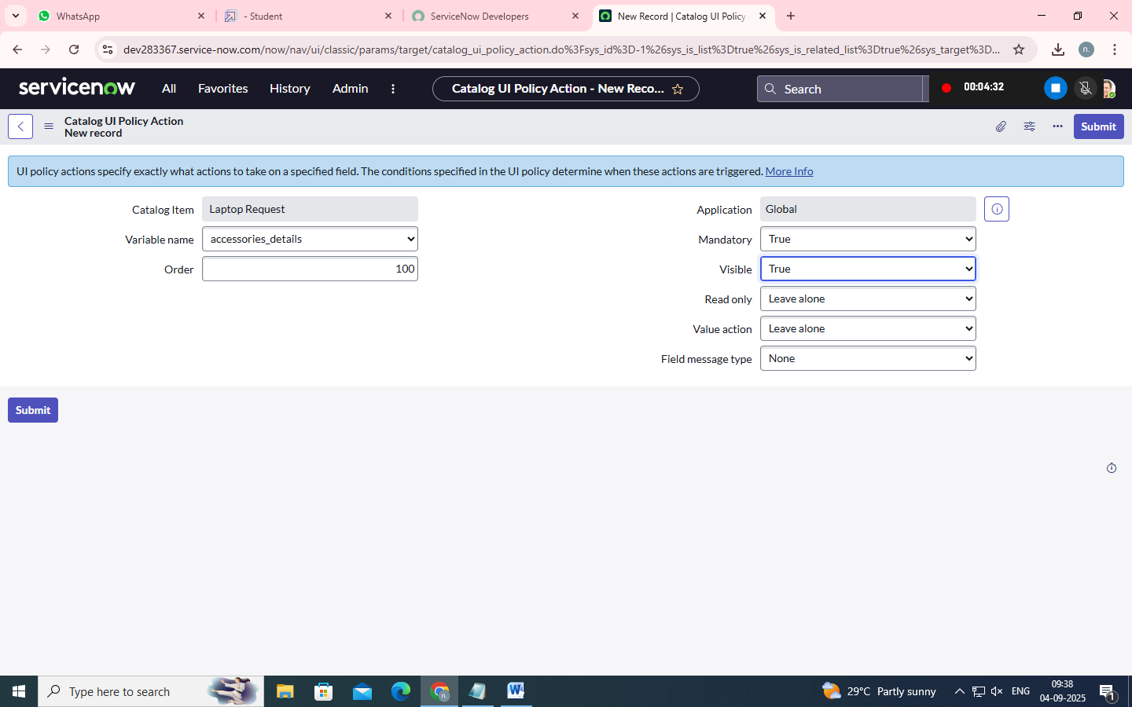

Ui Action

**Create Ui Action**

1.Open service now.

2.Click on All >> search for ui action

3.Select ui actions under system definition

4.Click on new

5.Fill the following details to create ui action

Table: shopping cart(sc_cart)

Order:100

Action name: Reset form

Client : checked

**Script:**

function resetForm() {

g_form.clearForm(); // Clears all fields in the form

alert("The form has been reset.");

}

Click on save

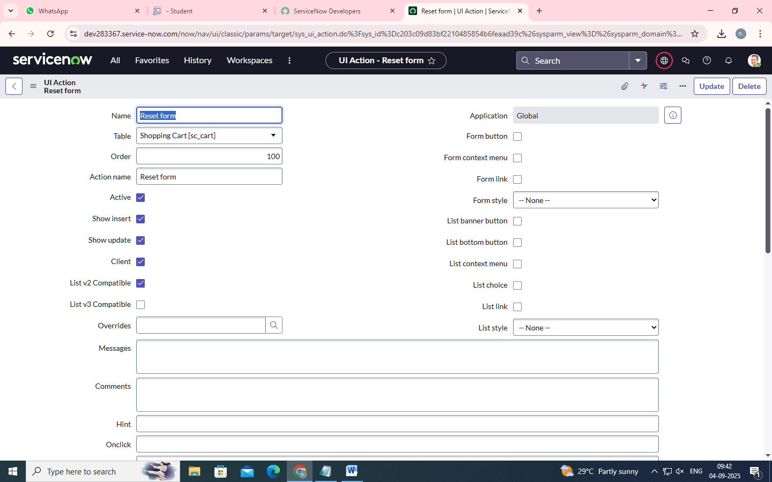

Export Update Set

**Exporting Changes To Another Instances**

1.Click on All >> search for update sets

2.Select local update set

3.Select created update set i.e. ‘Laptop Request Project’

4.Set the state to ‘Complete’

5.In the related list Update tab, updates are visible which we perform under this update set.

6.Click on export to XML ,it download one file

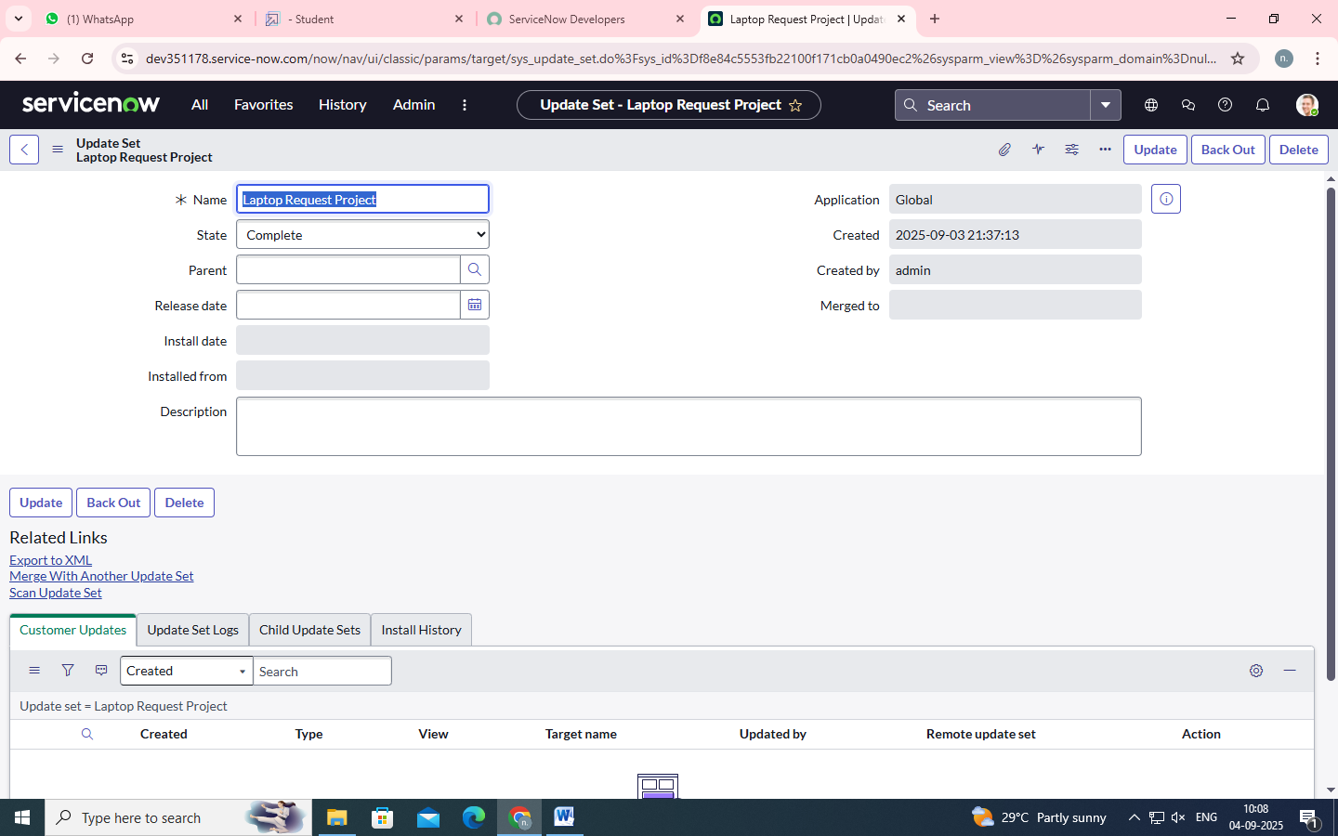

Login To Another Instance

**Retrieving The Update Set**

1.Open another instance in incognito window

2.Login with credentials

3.Click on all>> search for update sets

4.Select “Retrieved update set” under system update set

5.It open retrieved update set list and scroll down

6.Click on Import update set from XML



7.Upload the downloaded file in XML file

8.Click on Upload and it gets uploaded.

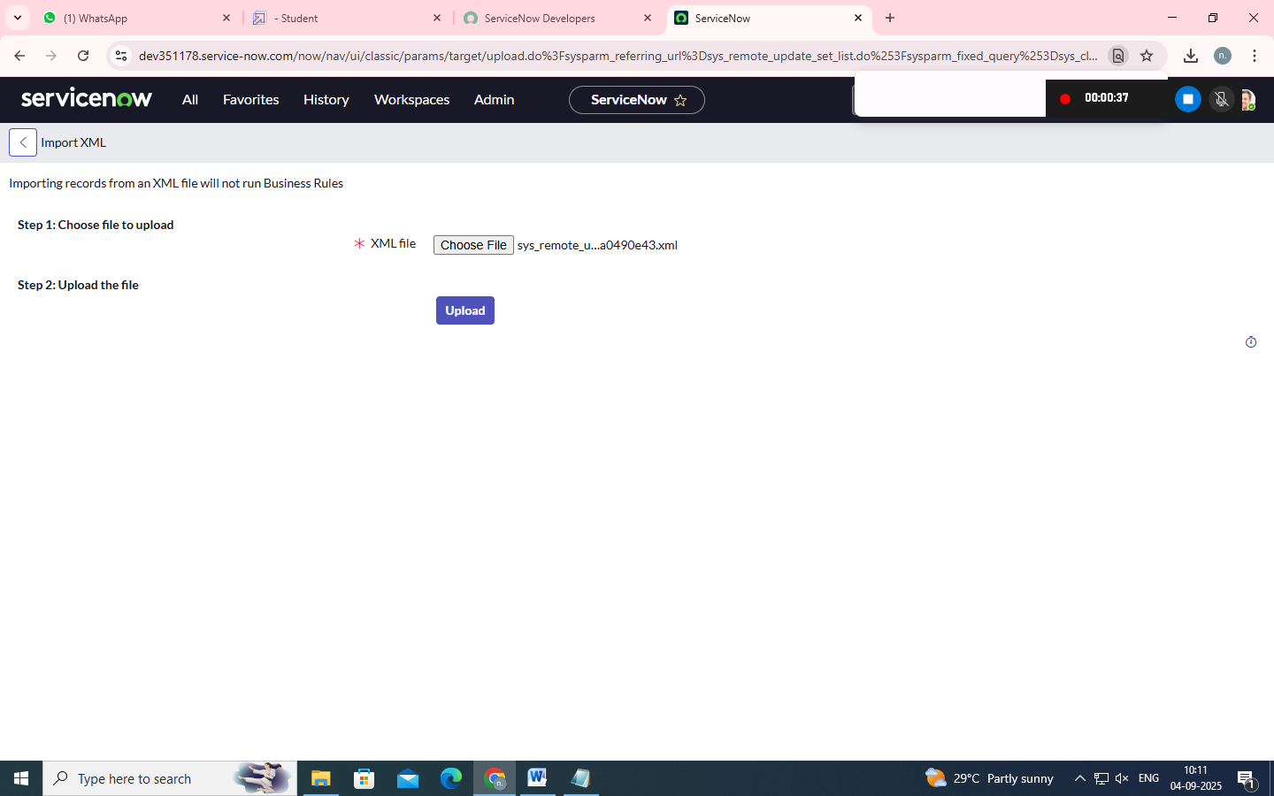

9.Open retrieved update set ‘laptop request project’

10.Click on preview update set

11.And click on commit update set

12.And also see the related tab updates

13.After commiting update set in this instance we get all updates which are done in the previous instance

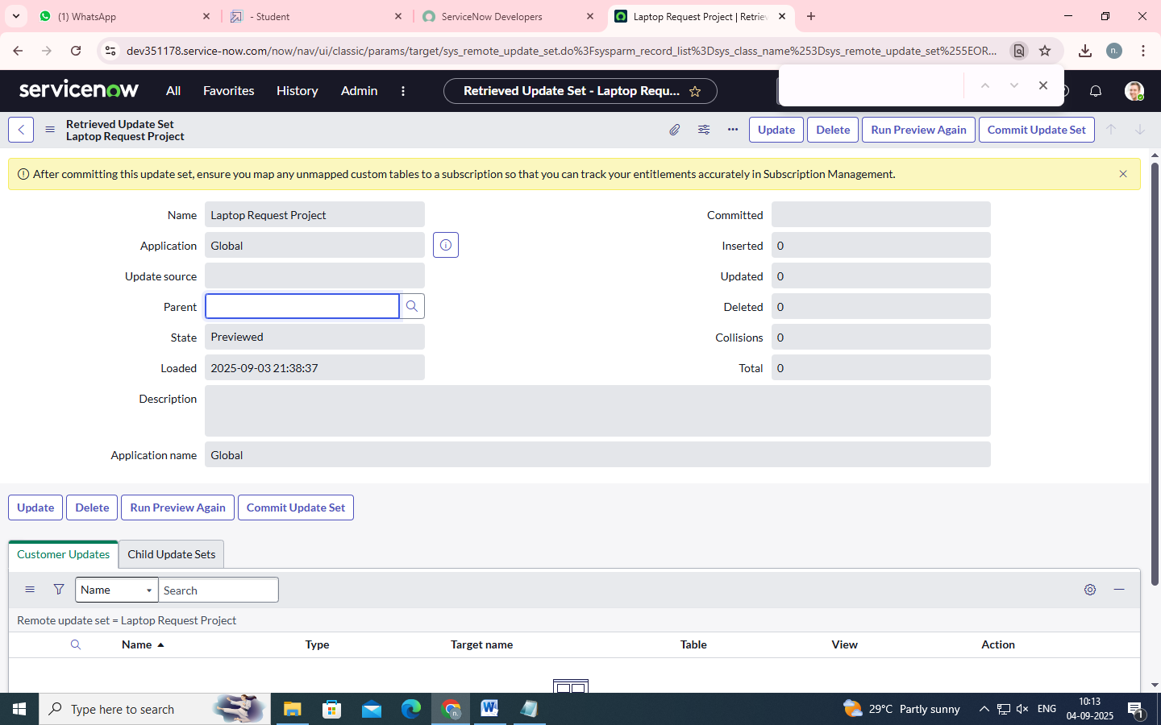

Testing

**Test Catalog Item**

1.Search for service catalog in application navigator in target instance

2.Select catalog under service catalog

3.Select hardware category and search for ‘laptop request’ item

4.Select laptop request item and open it

5.It shows three variables only

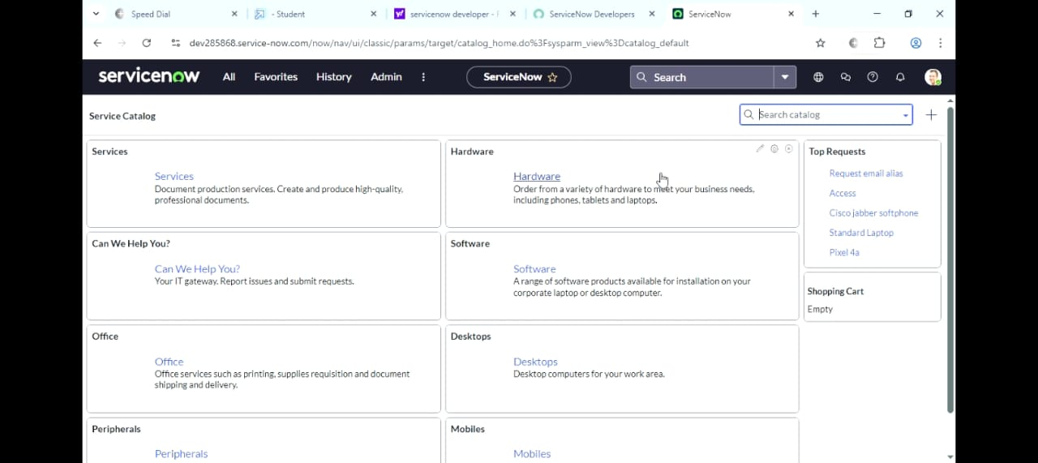

6.As per our scenario, when we click on additional accessories checkbox then accessories details fields is visible and that should be mandatory

7.Now see the results, it fulfils our requirements.

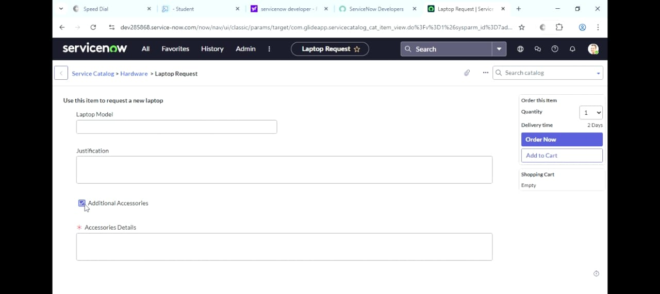

Conclusion :

The Laptop Request Catalog Item project successfully streamlines the process of requesting laptops within the organization by leveraging ServiceNow's Service Catalog capabilities. Through the implementation of a dynamic catalog item, the project ensures that users have an intuitive and user-friendly interface, reducing errors and improving efficiency.This project demonstrates how ServiceNow can be used to replace manual, error-prone processes with automated, efficient, and user-centric solutions. It not only improves service delivery but also enhances employee satisfaction by providing a modern and streamlined request experience.